**Flight Control System:**

**Overview:**

The purpose of the flight control system is to provide reliable indoor flight for a quad-rotor vehicle when a characterized/reliable position estimate is available, and when a set of desired locations/poses are commanded.

This system will accept a desired position in map space, given a North-West-Up coordinate system (used as per autopilot specifications), as well as a yaw command. These commands will be sent from the planning subsystem. Additionally, the SLAM algorithm described in the perception subsystem will provide position and orientation estimates to be used in the estimators used for control.

These commands and estimates are sent to an onboard Pixhawk autopilot. The autopilot uses these estimates and commands to run it’s internal control algorithms, which interface directly with the motors and ESCs. The Pixhawk uses a successive loop closure approach with position control as the outer most loop and the inner loops consisting of velocity, attitude, and attitude rate controllers.

**Modeling:**

**Hardware:**

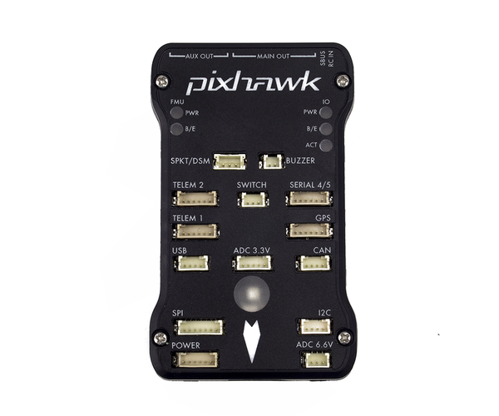A 3DR Pixhawk autopilot is being used as the low-level flight controller and state estimator.

The Pixhawk internally uses accelerometers built into the unit to estimate its orientation. It also has a built in barometer for altitude state estimation; however, this is not being used since the barometer estimates are unreliable even over a short time frame. The magnetometer onboard the Pixhawk can also provide yaw estimates.

The PX4 firmware is being used in our system. This firmware is convenient for this application because it has built in support for external pose estimates. This allows the use of VICON for pose estimates during the controller performance evaluations, initial flight-testing for waypoint following, and for testing of the planning subsystem. Additionally, this topic will be used in the final flight configuration, in which a SLAM solution provides the pose estimates.

Figure : Pixhawk Autopilot

INSERT FIRMWARE VERSION HERE

**Interfaces:**

The communication between the planning subsystem, perception subsystem, and the flight control subsystem is handled using the Robot Operating System (ROS). The MAVROS library allows direct communication with the PX4 firmware running on the Pixhawk. This allows the team to set parameters on board the Pixhawk easily, and even during flight which is extremely convenient for tuning controller and estimator gains and other flight parameters.

Additionally, the MAVROS interface is used to publish pose estimates and pose commands to the internal Pixhawk topics. The following topics are used in MAVROS:

INSERT LIST OF TOPICS HERE

INSERT MAVROS VERSION HERE

**Coordinate Systems:**

The following list of coordinate systems is relevant to the control system:

1. VICON: (???)
2. Pixhawk: (North-East-Down) the coordinate system used by the Pixhawk internally (???)
3. MAVROS: (North-West-Up) the coordinate system that is expected when passing position commands and estimates to MAVROS topics.
4. SLAM: (???)

**Results:**

After the coordinate system transformations were discovered and implemented in ROS nodes used to convert between coordinate systems, a successful flight test was performed that tested the waypoint tracking capabilities of the system.

These results demonstrate the successful development of a test bed for future work on the integration of planning and perception algorithms.

**Future Work:**

The future work for this subsystem includes the further tuning of control gains, and the integration of the subsystem with perception algorithm pose estimates. Once this system is integrated with the SLAM system, further tuning of control gains will be needed in order to compensate for the SLAM position estimate performance, which at this point is being characterized.